Treating Allergies with Radionics Homeopathy
Our bodies are quite good at keeping us going, but showing unease in the body with congested sinus’s, dripping nose, rashes, upset stomach muscle pains, headaches, restlessness.

- Best solution to get rid of your allergies: Get your allergen support remedy following a full assessment of all things your body maybe reacting to loudly and quietly. From pesticides, heavy metals, foods (including gluten, wheat, dairy, nuts),moulds, fungi, pollens (grasses, tree pollens, bloosom pollens, other pollens), insects (bees, mosqitos) Animal hairs(rabbit, horse, cat and dog), EMF’s. Muscle testing with the allergen vials is effective and less expensive than a blood test. And after a few weeks retesting will show an improvement or complete recovery of the Allergen. Full workup session to test for all possible Allergens is available. Be given vibrational remedy for the group of allergens that you would first like to help the body desensitize from. Be given information on Diet to help the process of sensitising from your allergens and recommended probiotics and omega 3.
- Buy an ‘allergy’ (combination remedy) that you think you need $25 (30ml)
- Include Bowen Therapy to help destress your body and support your immune system.
Allergies are really just a part of a much bigger imbalance. Mental health and physical health play a big role in helping the body recover. Bowen Therapy is a way to help with improving over-all body balance. Bowen therapy has helped improve lung function, and helped liver and kidneys function better,and support for digestive and bowel issues. Radionics can make the vibrational imprint of homeopathic remedies. No need to order homeopathic pills. The same effect gained in homeopathic remedy can be made with the vibrational blueprint of the specific remedy. Specific remedies can be made to support circulation, joints, heart health and more.
The main benefit of this combined approach is that your body has a better opportunity to return to a sounder and more resilient state of health.
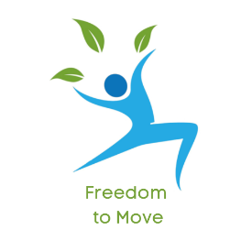
Contact Louise Parkin in Havelock North. Ph 0223157879.

www.freedomtomove.co.nz
Creating more comfort in your body.

